URBAN MOBILITY & PUBLIC SPACES STRATEGY BACKGROUND REPORT
November 2024

- INTRODUCTION
This Urban Mobility & Public Spaces Strategy (UMPSS) is not just a plan, it is a catalyst for change. It identifies the key place and movement opportunities and challenges within the city centre and proposes investment in enhanced transport and public space for both the immediate and longer-term future. This will help ensure that Liverpool is a thriving place to live, work and visit in 20 years’ time in 2045. This strategy does not just stop at planning, it should be read as a document that can help inspire change
The success of this strategy hinges on the involvement and buy-in of the people of Liverpool. Their needs and demands will guide our path beyond this document.
The cornerstone of this strategy is to build a city centre where transport solutions enhance Liverpool's distinctiveness while ensuring its prosperity and sustainability. Our mission is to make Liverpool a shining example of a city where an integrated transport system of public transport, active travel and taxis and vibrant public spaces come together to create a truly exceptional urban experience.

WHAT IS THIS URBAN MOBILITY & PUBLIC SPACES STRATEGY?
This Urban Mobility & Public Spaces Strategy presents a long-term plan for all types of movement in our city centre, offering a clear blueprint for more active and sustainable movement. Rooted in a bold aspiration for the city’s growth, it serves as a visionary document guiding us towards a more sustainable and vibrant future where our communities flourish, sustainability thrives, and transport networks connect seamlessly
​Throughout this analysis, the strategy has identified three key mobility pillars: 'People,' 'Place,' and 'Movement.' This allowed us to explore mobility beyond transportation, considering its impact on all aspects of the city's development and functionality.
​The issues and opportunities identified provide a foundation for this strategy to propose what Liverpool's mobility could look like in 2045, with proposed short and medium interventions* acting as a catalyst for changes to be shaped and defined by the city's residents in the years to come.
*going to need some clarity on what short term and medium term actually means? Short term = next two years? Medium term between 3-5 years?
Immediate progress will be evident through the introduction of quick-win schemes, followed by long-term accelerated projects
This Urban Mobility & Public Spaces Strategy is not intended to be the sole solution to the city's mobility challenges, but rather a call to initiate change. It should kick-start a generative design process where key stakeholders and local people contribute and lead changes to the city's mobility, ensuring it genuinely reflects the city and its people.
Ensure projects have a project champion to help maintain momentum.*
*does that mean each individual project has a project champion? Within the council? Officer or elected member?

WHY NOW?
THE CLIMATE EMERGENCY
The Liverpool City Region Combined Authority (LCRCA), was the first combined authority to declare a climate emergency. Transport is a significant contributor to carbon emissions in the city, so improvements to transport represent a key opportunity to reduce carbon emissions*.
*transport is the 2nd largest sector contributing to carbon emissions, the current transport system is completely at odds with the stated objective of getting to net zero emissions by 2030/2035 and will need to be completely transformed if it is going to become a net-zero system

THE CITY TRANSPORT PLAN
The recently adopted City Transport Plan aims to reduce CO₂ emissions and decrease the number of car journeys in the city, which currently account for almost two-thirds of all journeys and generate nearly half a million tonnes of CO₂ emissions annually.

EVENTS AND CULTURE BOOM
Liverpool hosts numerous events in unique venues across the city, with residents and visitors able to experience world-class arts and culture. Liverpool is on track to return to pre-COVID levels of tourism

EXISTING AND UPCOMING STRATEGIES
It is essential for the city to invest in infrastructure to support its sustainable growth. Efforts are underway to improve transport in line with the city's changing landscape
Furthermore, the city’s Public Realm Strategy (2022) has been developed to guide design and access for high-quality public spaces. The Public Realm Strategy sets out a "People First City" vision which begins to draw together the key aspects of public realm and movement. The strategy, in particular, places great emphasis on active travel and the accessibility of public spaces.

WHAT IS MOBILITY?
Mobility is more than just transport, but how do we define it?
The simplest definition of mobility is the ‘ability for an individual to freely move or be moved’. In an urban context, it encompasses all modes of transport.
Overview: Mobility is a key dynamic of urbanisation, and the associated infrastructure invariably shapes the urban form – the spatial imprint defined by roads, transport systems, spaces, and buildings – of cities
The Challenge: Cities of today are trafficchoked, road crashes kill a total of 3,287 people a day, and transport-related emissions are on the rise. The world needs to move towards safe, affordable, accessible, integrated and sustainable transport systems
So far, the standard response to addressing urban mobility issues typically has been to increase infrastructure, mostly for cars, such as building more roads, highways, flyovers, or tunnels. Unfortunately, these developments engender a vicious circle: more infrastructure stimulates urban sprawl because access to peripheral urban areas is eased, increasing the use of cars which, in turn, calls for further infrastructure development, and so on.
- UN-HABITAT, 2019

• What does mobility look like now?
• What should mobility in the city centre look like in 2045?
• How does the city navigate between present day and the aspirations for 2045?

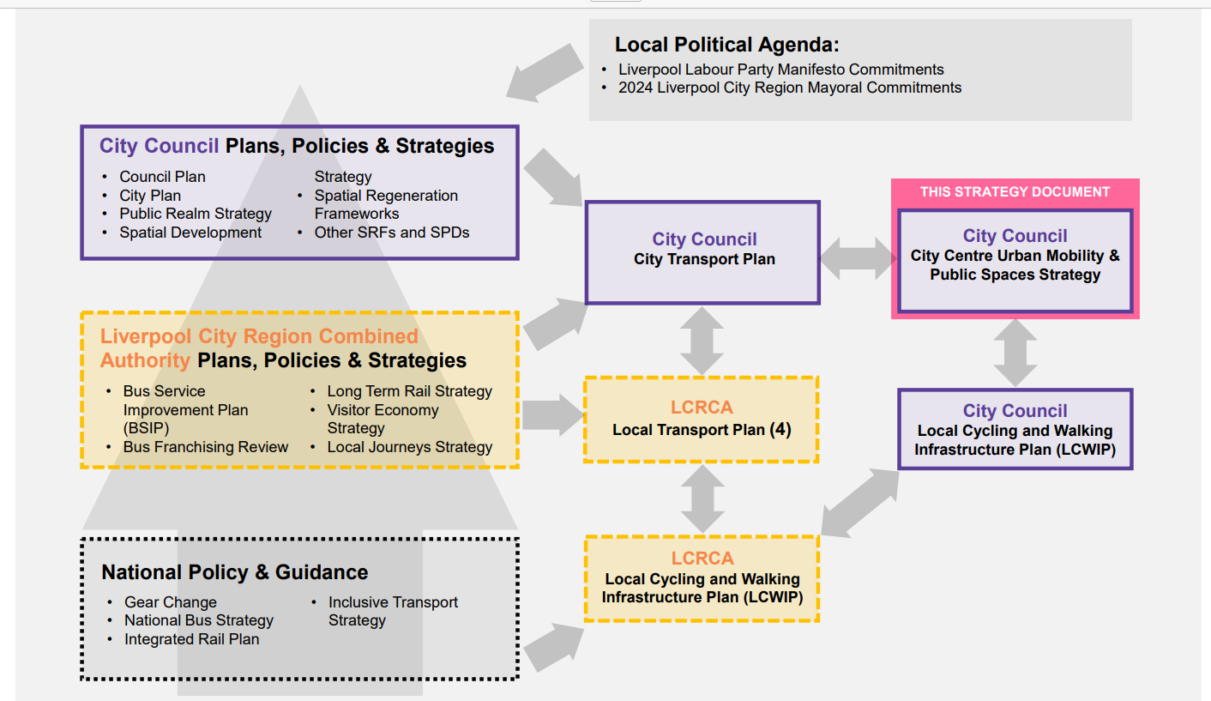

2.0 VISION
WHAT IS LIVERPOOL’S MOBILITY VISION?
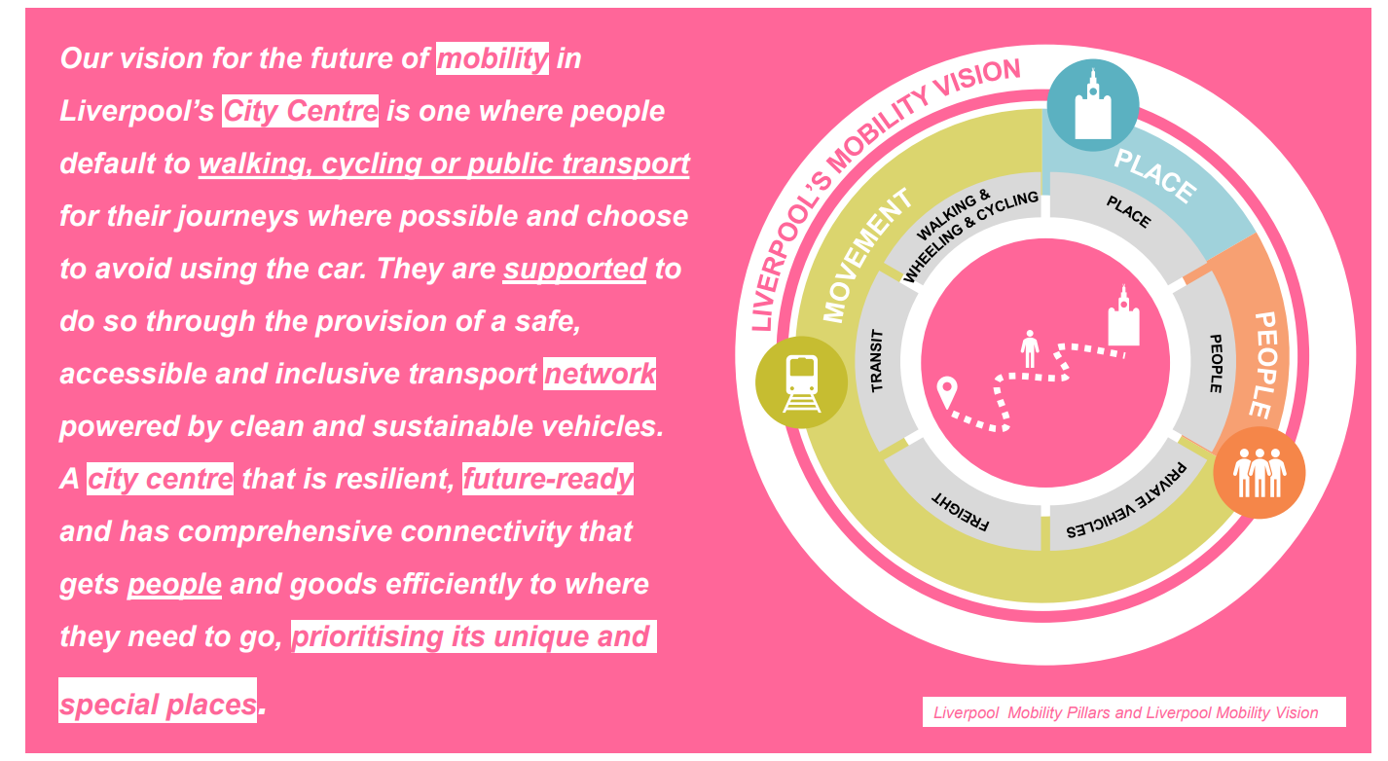

MOBILITY PILLARS
The Mobility Pillars have been designed to guide the approach to mobility in the city centre study area. The pillars have been created through an understanding the key components of mobility universally and through understanding what makes Liverpool City Centre unique
PEOPLE: the "People" pillar focuses on the human element of mobility. It seeks to create transportation systems and infrastructure across Liverpool that prioritise the needs and experiences of individuals*. This pillar aims to provide accessible, safe, and inclusive mobility options for all Liverpool residents, workers, and visitors. It addresses issues such as equitable access to transportation, pedestrian and cyclist safety, and ensuring that mobility solutions are designed to meet the diverse needs of Liverpool's community.
*don’t the needs and experiences of individuals conflict sometimes?
PLACE: The "Place" pillar is centred around the urban environment and the quality of spaces within Liverpool. It emphasises creating vibrant, liveable, and attractive places that promote a sense of community and well-being. This includes designing transportation systems that enhance the aesthetics of Liverpool's urban areas, reduce congestion, and improve the overall quality of place. It's also about ensuring that mobility solutions are integrated into Liverpool's urban fabric to support local businesses, cultural activities, and public spaces.
MOVEMENT: The "Movement" pillar is all about the efficient and effective flow of people and goods within Liverpool. It addresses the functionality and connectivity of transportation networks, including roads, public transit, cycling routes, and pedestrian walkways. This pillar focuses on reducing congestion, improving transportation efficiency, and enhancing connectivity to ensure that people and goods can move easily and swiftly throughout Liverpool.

This Urban Mobility & Public Spaces Strategy focuses on the city's centre, as shown in the adjacent map
While this strategy focuses on the city centre, the aim of this report is to enhance mobility across the entire city. It's important to note that mobility challenges identified in the city centre often affect the wider city region. Furthermore, the city centre serves as a hub for the entire city region and beyond, offering vital connectivity at its boundaries with neighbourhoods such as Bootle, Everton, Kensington, Wavertree, and Toxteth.
These areas will be directly affected by mobility proposals within the city centre. Thus, addressing mobility issues within the city centre is crucial to improving transportation across the broader city region

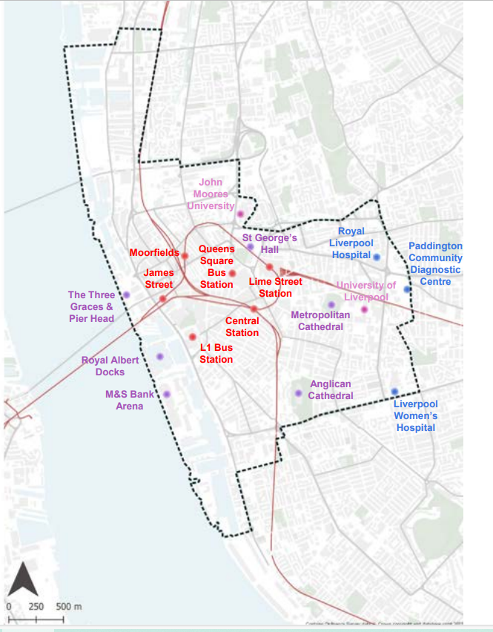

3.0 PEOPLE
Liverpool's population has grown by 4.2% from 2011 to 2021, although this rate is slightly slower than the national and regional averages. In 2021, Liverpool ranked second in population density amongst the 39 local authority areas in the North West, highlighting its local and national significance.
POPULATION DENSITY
Liverpool's central area is densely populated and features commercial and residential clusters, and a large student population.
Contrastingly, the northern city centre and waterfront areas historically featured lower population densities, primarily due to their industrial focus. However, these areas are currently experiencing transformation through new developments (e.g., Liverpool Waters). Similarly, areas surrounding significant infrastructure (e.g., tunnel gateways and parks) also exhibit lower population density.
What Do We Need To Do?
Population density plays a pivotal role in shaping the effectiveness and sustainability of an efficient public transport network. Identifying areas with low population density and delivering land use change to increase population density is crucial for enhancing the viability of high quality and high frequency public transport. Greater residential density allows for more cost-effective establishment and maintenance of transit routes. This, in turn, leads to more efficient resource allocation, enabling investment in improved transport infrastructure and expanded services. Such developments further foster social equity, offering accessible transport options across various socioeconomic groups
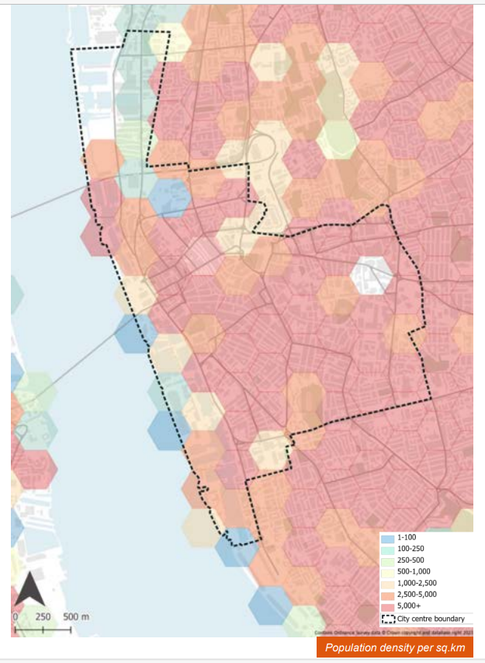
DEPRIVATION
There are seven indicators which calculate the Index of Multiple Deprivation. These are weighted in terms of their importance:
• Income Deprivation (22.5%)
• Employment Deprivation (22.5%)
• Education, Skills and Training Deprivation (13.5%)
• Health Deprivation and Disability (13.5%)
• Crime (9.3%)
• Barriers to Housing and Services (9.3%)
• Living Environment Deprivation (9.3%)
Liverpool City Centre is at the heart of the city’s economic and social activities and has the lowest levels of deprivation. The centre benefits from higher levels of investment, infrastructure, and access to amenities. The concentration of businesses, employment opportunities, entertainment venues and educational institutions can contribute to a higher quality of life for its residents.
In stark contrast, the outskirts of Liverpool are home to some of the most deprived areas in the UK. These areas face socio-economic challenges and are influenced by factors such as lack of investment, fewer job opportunities, and limited public transport.

What Do We Need To Do?
Efforts to enhance public transport and connectivity to and from the city centre could help to bridge the gap between the core and the periphery. This would help to make essential services and opportunities more accessible to residents in deprived areas and provide more equitable movement for all.
This means that proposals put forward for the city centre and any city-wide schemes should aim to support low-cost and convenient sustainable transport options and movement. This will ensure that transport interventions do not further entrench deprivation in areas surrounding the city centre, whilst promoting growth and investment into these areas.
“Those living in the most deprived areas of England and Wales were 318% more likely to use public transport.” – UCL, 2021¹

HEALTH
Liverpool, like many cities, experiences spatial disparities in health outcomes between the city centre and other areas.
Cancer, cardiovascular and respiratory diseases are the leading causes of premature mortality in Liverpool.*
*I’m pretty sure there are studies that show how active travel and cycling has positive impacts on populations on all of those areas of disease.
25% of children in Year 6 are classified as obese in Liverpool
The prevalence of depression in Liverpool is above the English average
Liverpool ranks in the top 10 worst areas for poor lung health

ACCESSIBILITY
In the 2021 Census for England and Wales, figures revealed that over 100,000 people in Liverpool reported having a physical or mental impairment which had a substantial and long-term impact on their lives.
What Do We Need To Do?
With over a quarter of Liverpool's local population classified as disabled, it is imperative to focus on inclusive street and public space design to enable equitable city centre mobility. Streets cluttered with excessive furniture, narrow or uneven pavements, and obstacles like poorly placed signs or crowded outdoor seating create significant hurdles for wheelchair users, individuals with limited vision, people with restricted mobility, and parents with pushchairs
Furthermore, streets should be designed with accessible public toilets, comfortable seating areas, and shaded spaces to accommodate the needs of those with disabilities. This will ensure that all residents, regardless of their physical abilities, can comfortably navigate and enjoy the city centre

AIR QUALITY
The City of Liverpool has been designated as an Air Quality Management Area (AQMA) by DEFRA, as illustrated in the adjacent map. Presently, Liverpool ranks as the 22nd most polluted city or town in the country per 10,000 people due to its levels of nitrogen dioxide.
The majority of nitrogen dioxide emissions result from transport-related sources, originating from the combustion of petrol and diesel. Combustion engines in vehicles burn fossil fuels, emitting various pollutants into the atmosphere, which adversely affect air quality and public health. Liverpool holds the unenviable distinction of having the third-highest incidence of childhood asthma cases in the UK*
Considering that vehicle traffic is responsible for 70% of the city's pollution, it becomes imperative to reduce vehicle traffic to enhance the overall health of residents
*we do need to understand the contributions of indoor and outdoor air pollution in public health outcomes like respiratory health and others. Liverpool also has lots of old, cold and mouldy homes and this is a significant factor as to why respiratory disease and asthma rates are so high. We need to make sure we are aware of this when we discuss air pollution.

What Do We Need To Do?
Overall, poor air quality presents a significant threat to the health, well-being, and prosperity of a city and its residents. Therefore, improving air quality stands as a crucial goal for the city centre.
Substantially reducing the use of vehicles is essential for curbing the volume of air pollutants in the city. Investment in active travel and public transport should facilitate this transition away from an over-reliance on polluting vehicles.

GREEN SPACE
Although Liverpool is well-provided with green spaces, including large public parks such as Everton Park, Anfield Park, Princes Park, and Sefton Park that offer great access to green areas, the city centre faces a challenge in terms of green space availability.
What Do We Need To Do?
In urban areas like Liverpool City Centre, incorporating green spaces can be challenging due to limited space. Nevertheless, green spaces offer vital health and environmental benefits and should be integrated into streets and public areas whenever possible.*
*if you want high population density in the city centre that means you don’t get much green space. Land is incredibly valuable in the city centre generating revenue for residential and commercial properties. The potential for creating green space is limited (significant green space like parks). Everything should be done to provide whatever plants and trees that can be well landscaped in but there aren’t going to be parks in the city centre.

CULTURE
Globally, Liverpool is known for its contributions to music, art, and sports, which attract over 31.5 million tourists and contribute £5bn per year, playing a vital role in the city's economy.
What Do We Need To Do?
Liverpool must secure the ongoing success of its culture and tourism future by developing suitable infrastructure for new destinations and existing events. This supporting infrastructure must address the issue of car congestion, which frequently occurs on days of major events.
In 2022, the local economy received an impressive £3.58 billion uplift from tourist spending, compared to £2.45 billion in 2021 – up 46%
The city welcomed 31.5 million visitors in 2022 compared to 23.9 million in 2021 – a 32% increase*
*are these visitors from outside the city region or does that include people coming from the Wirral, Sefton and Knowsley?

NIGHT-TIME ECONOMY
Liverpool is home to a thriving night-time economy and has earned a great reputation for its lively nightlife. Night-time is equally as important as day-time when considering transport coverage, and Liverpool City Centre should incorporate elements that promote safety during the night hours. This would help to make it an inclusive and accessible city for all, at all times of the day

What Do We Need To Do?
A safe transport network, 24-hours a day will encourage the use of sustainable transport during night-time events. These transport networks enable visitors and residents to travel through Liverpool during the night, boosting the nighttime economy and reducing over reliance on taxi services.

4.0 PLACE
Places are for people and people make places special, so the city centre must make the space for people to come
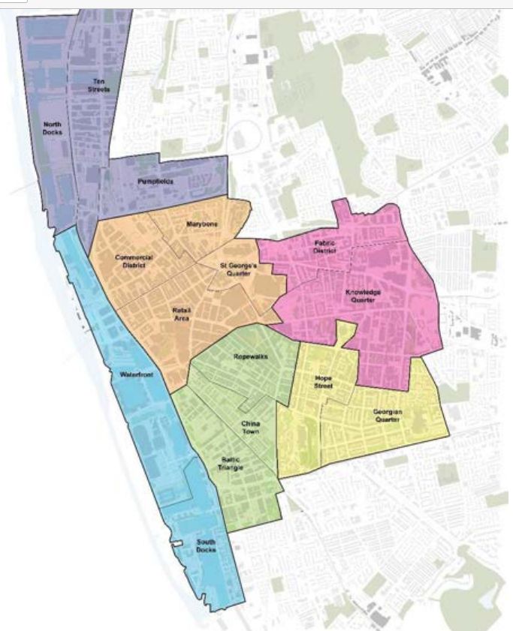
City Centre Neighbourhoods
- North Docks
- Ten Streets
- Pumpfields
- Commercial District
- Marybone
- St Georges Quarter
- Retails area
- Waterfront
- South Docks
- Ropewalks
- China Town
- Baltic Triangle
- Hope Street
- Georgian Quarter
- Fabric District
- Knowledge Quarter

REVIEW OF PUBLIC REALM, GREEN INFRASTRUCTURE AND HERITAGE
What Do We Need To Do?
Whilst the city centre largely retains its historic and dense street grid, highways interventions in the mid and late 20th century have drastically changed the character of the area. Public spaces have become dominated by vehicles and pedestrian areas have become severed with the presence of guardrails and large, staggered crossings.

CHARACTER AREA ANALYSIS
The city centre is made up of a number of diverse character areas, each with its own distinctive character and form. This Urban Mobility & Public Spaces Strategy has defined six character areas, using information on ward boundaries and their associated characteristics. The six character areas are defined in the adjacent plan and below as:
• North Docks consisting of Liverpool Waters, Ten Streets and Pumpfields
• City Centre Core including Commercial District, Retail Core, Marybone and St George’s Gateway
• Knowledge Quarter and Fabric District
• Georgian Quarter including Hope Street
• Ropewalks and Baltic Triangle including Chinatown • Waterfront and South Docks.
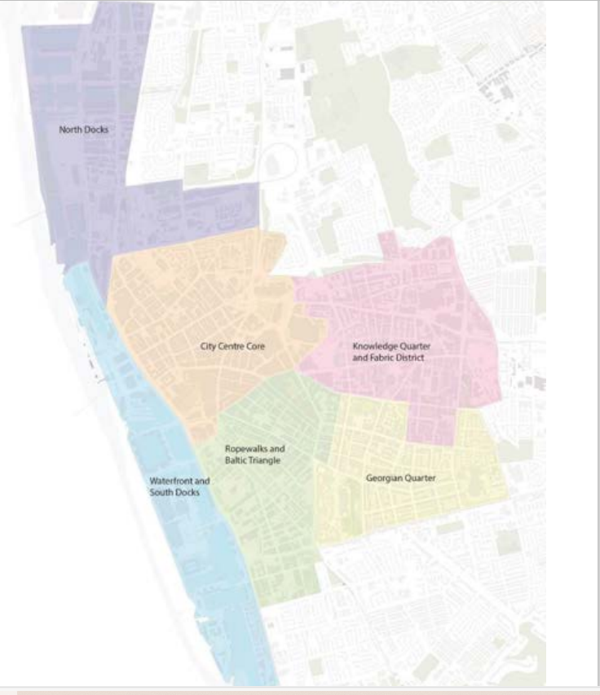

CHARACTER AREA ANALYSIS – CITY CENTRE CORE
What Do We Need To Do?
High potential for becoming a wide-reaching precedent of a people-oriented car-free city centre core.
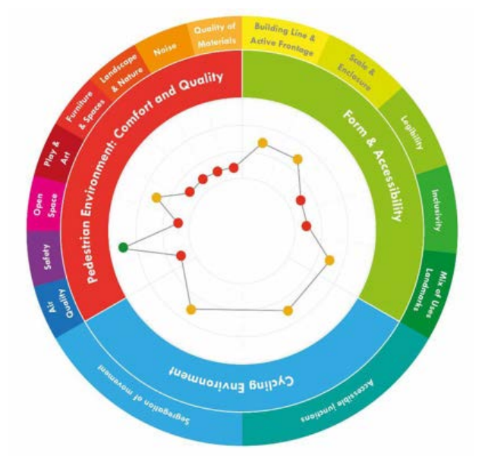
They seem to have created their own tool for quantifying various aspects of the urban realm;
- Cycling environment – segregation of movement, accessible junction
- Pedestrian environment – air quality, safety, open space, play and art, furniture and spaces, landscape and nature, noise, quality of materials
- Form and accessibility- building line and active frontage, scale and enclosure, legibility, inclusivity, mix of uses Landmarks

CHARACTER AREA ANALYSIS – FABRIC DISTRICT & KNOWLEDGE QUARTER
Key observation points:
• High pedestrian activity along roads but junctions poorly designed.
• Dominance of highway and evidence of rat running.
• Challenging environment for cyclists due to topography and fragmented bike lanes.
• Buses and traffic dominate the area although providing good connectivity they influence the growth and quality of place.

What Do We Need To Do?
• Create enhanced opportunities for active travel to encourage movement shift.

CHARACTER AREA ANALYSIS – GEORGIAN QUARTER
Key observation points:
• High-quality materials, low traffic, positive social noise, good safety, and air quality foster a comfortable pedestrian environment.*
• Cycle movement either integrated with general traffic or shared with pedestrians within the university campus area.
*This is a very positive spin on the Georgian quarter, its still very much dominated by cars, either moving or parked.
What Do We Need To Do?
• Create clear routes for active travel and enhance opportunities for connectivity to city core.
*turn it into a low traffic neighbourhood/mini-holland?

CHARACTER AREA ANALYSIS – THE ROPEWALKS & BALTIC TRIANGLE
Key observation points:
• Limited bike lanes, resulting in a fragmented cycle network and absence of crossing infrastructure.
What Do We Need To Do?
• Improved cycle infrastructure and pedestrian environment
*turn it into a low-traffic neighbourhood/mini-holland

5.0 MOVEMENT
Transport can be the number one feature that holds cities back and it can also be the number one feature in propelling them forward.
Access to transportation and equitable mobility within the city of Liverpool varies depending on location, socioeconomic status, and various other factors. This becomes particularly evident when examining the statistics related to car usage. Despite only 60% of the city's population owning a car, vehicle mobility remains the primary means of accessing jobs in the city centre. Currently, driving in and to the city centre is the most convenient option for the majority of the population with a high volume of cheap car parks, large road infrastructure and access to the vast majority of the city centre.
What Do We Need To Do?
Implementing a hierarchy of transport modes that prioritises sustainable and active travel options (over more polluting modes) will enable the repositioning of city centre space to accommodate fewer damaging forms of transport.
This will make it easier and more convenient for those with limited vehicle access to move around the city. It will also lead to reduced pollution, congestion, and improved safety.
By fostering sustainable and active mobility, cities can create healthier, greener, and more vibrant urban spaces while addressing challenges related to pollution, public health, traffic congestion, and social inclusion.
- 31% of residents travel less than 5km to work
- Only 36% of people in Liverpool can reach the city centre by public transport in 30 minutes or less
- Only 12% of people travel to work using an active mode of transport (walk or cycle)
- Three times as many jobs are accessible in 30 minutes by car than by public transport from Liverpool
- 40% of residents in Liverpool do not own a car

ROAD SCALES
Arterial routes like A-roads often attract high volumes of traffic in the city centre, especially exacerbated by navigation systems that promote them as primary routes. Liverpool’s City Centre is constrained by several arterial routes, with key strategic links to the Wirral, Cheshire, and North Wales through the city's tunnels serving as necessary connections.
These tunnels play a vital role in mitigating the separation caused by the River Mersey but also contribute to the high traffic volumes around their landing points in the city centre.
What Do We Need To Do?
A-roads and wide highways within a city can lead to a transport network dominated by vehicles. This results in barriers to walking, wheeling, and cycling which hinders smooth movement between places.
Reducing the number of A-roads and narrowing lanes in specific city areas, particularly the central core, would prevent Liverpool from becoming a through-route and help to support sustainable travel. Mitigating the number of lanes on these key strategic roads would reduce the severance they cause, decreasing speed, air, noise, and visual pollution
As well as reducing numbers of regular traffic lanes, more work needs to be done to explore where new bus lanes can be created to help improve priority and journey times for local buses in the city centre
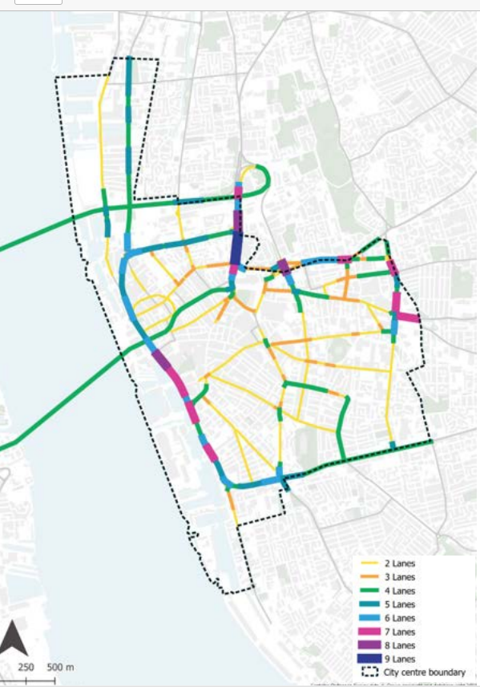

VEHICLE CONGESTION
Liverpool City Centre is known to experience congestion, especially during peak hours and busy periods. Several arterial roads, including The Strand, Parliament Street, Islington, and Leeds Street, constrict the city centre, each bearing an average of over 20,000 vehicles a day. Congestion is particularly pronounced during the morning and evening peak times.
The Kingsway and Queensway tunnels further exacerbate this issue by funnelling high volumes of traffic directly into the city centre. This creates a bottleneck in the road network and adds to the existing congestion, especially at the tunnel exits

What Do We Need To Do?
A congested road network creates stress, frustration, and delays, along with poor air quality.
Additionally, congestion disrupts the schedules of coaches, buses, and taxis, inconveniencing those seeking more sustainable travel options.
To alleviate congestion, private vehicles should be reduced on the road network. Encouraging carpooling, cycling, walking, and public transport can mitigate congestion's effects and create a cleaner, healthier city for travel.*
*all the above should be encouraged, but also driving a private car into the city centre should be heavily discouraged. It should heavily restricted where you can drive a private car in the city centre, effectively banning private cars from entering where possible and restricted where they can drive. It should be impossible for a private car to drive through the city centre. They can go around, not through.
Furthermore, improving walking, wheeling and cycling infrastructure is crucial to shift people from private vehicles to active and sustainable modes. Promoting public transport for longer journeys can help alleviate congestion and enhance air quality, especially in light of Liverpool's designation as an Air Quality Management Area (AQMA) across the entire city

STRATEGIC & LOCAL FREIGHT & SERVICING
What Do We Need To Do?
A potential solution could involve creating designated delivery zones, implementing delivery time restrictions, or encouraging the use of smaller electric or alternative fuel vehicles (micromobility) and last mile micro delivery and collection hubs

CAR PARKING
Liverpool has a range of available car parking options across the city centre. However, the scale and locations of both on and off-street car parking add significant congestion to selected city centre streets. Volumes of traffic across the city centre adversely impact quality of environment and the efficiency and attractiveness of walking, wheeling and cycling as well as public transport journeys.
On-street parking is prevalent in areas including the Baltic Triangle, Hope Street, the business district and the Georgian Quarter. On-street parking regulations and availability vary by location and time of day.

What Do We Need To Do?
The central locations of publicly available car parks add significant vehicular traffic to roads in the heart of the city centre. City centre congestion adversely impacts public transport journey times and contributes to a poor environment for pedestrians and cyclists.*
*eradicate on-street parking withing the UMPS zone between 2025-2030 (residents only but make them pay)
*phase out surface level car-parks within the UMPS zone 2025-2030
*longer term centrally located multi-storey car parks to be relocated and closed, 2030-2035.

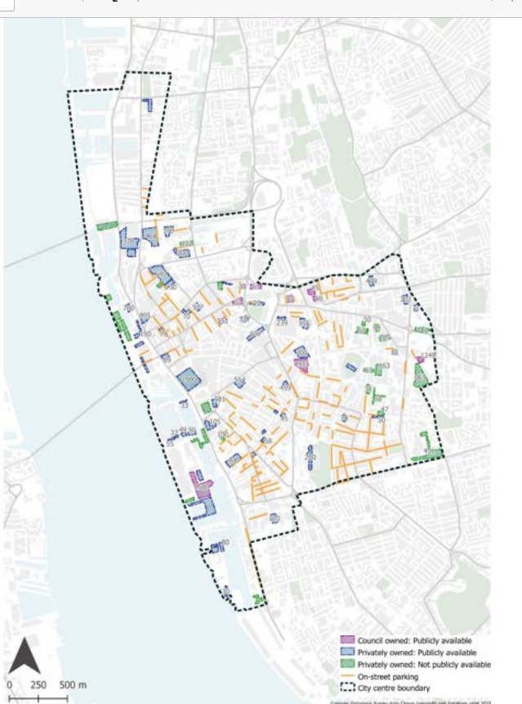

Alex, did they speak to you about this bit?

NETWORK MOVEMENTS
However, it's worth noting that some modal filters, like the one on Hanover Street, lack enforcement limiting their effectiveness. Ideally, access on routes such as this should be limited to buses, taxis, and cyclists only.*
*is the bus gate on Hanover street not being enforced?
What Do We Need To Do?
The road network shapes a city's character and supports sustainable transport through measures like pedestrian zones, modal filters, green spaces, bus lanes, and one-way streets, minimising cross-city routes and deterring unnecessary through traffic.
Expanding pedestrian areas can create safer, more vibrant spaces that encourage social interaction, help local businesses, and foster sustainable urban living, enhancing overall quality of life.
Strictly enforced bus lanes improve transport efficiency, cutting travel times, reducing congestion, and promoting eco-friendly travel, making public transport more appealing. These types of schemes will be implemented as a priority within the city.
RAIL NETWORK
Lime Street Station and Liverpool Central Station serve as vital transport hubs in Liverpool, managing a significant flow of national and regional services. Significant volumes of patronage at these stations are due to visitors to the city with peak usage often reflective of the strong tourism and visitor economy in Liverpool (peak being a Saturday Afternoon). Furthermore, Moorfields and James Street collectively handle only a quarter of all arrivals
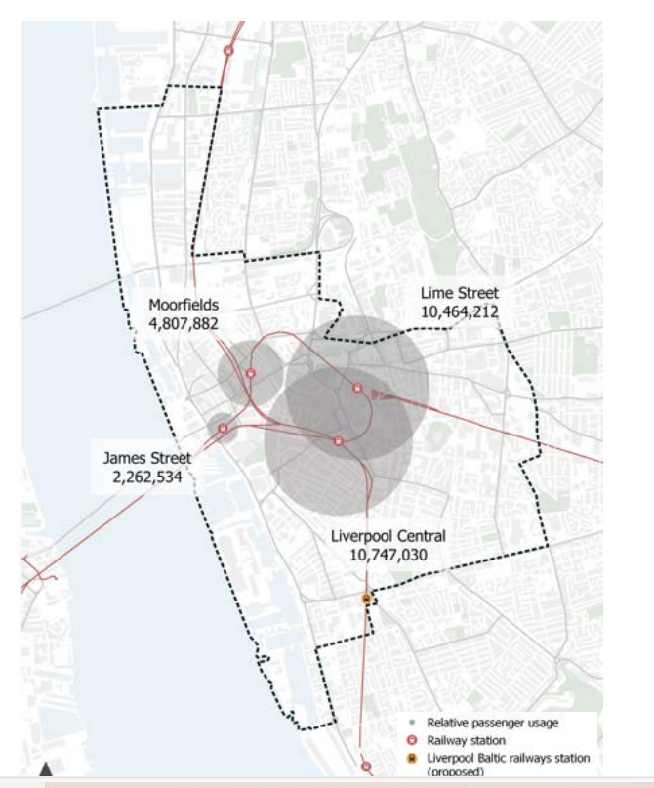

BUS NETWORK
Liverpool's bus network is predominantly operated by Arriva and Stagecoach, overseen by Merseytravel. Nevertheless, a significant shift is anticipated, mirroring Greater Manchester's approach, as Liverpool Combined Authority gears up to franchise its bus services
What Do We Need To Do?
Liverpool should be aiming to deliver a bus network with the level of frequency, coverage and priority that is seen in London’s bus network. We need to learn from cities such as London when developing plans for a regulated bus network.*
*I don’t think that is feasible/viable. London can sustain much higher numbers of buses and many more routes because of the huge population and high population density. We should definitely be aiming for a significantly improved bus network but doubt we’ll reach the heights of what London can provide
- 400,000 bus passengers cross the city region in a single day¹
- 72.3 million bus passenger journeys were taken in Merseyside during 2022/23
- 32% of passenger trips were elderly and disabled concessionary trips
- 15% of journeys to work within the city of Liverpool were taken by bus
CYCLING VOLUMES
Liverpool's cycling rates are notably lower compared to other British cities like London, Bristol, and Oxford. However, in the broader context, cycling levels across British cities are generally lower compared to European counterparts such as France, Belgium, Sweden, and Germany. The current volume cyclists in Liverpool indicates that it is an underutilised mode of transport for many residents in the city.
Future aspirations for cycling levels in Liverpool can be explored using the Propensity to Cycle Tool (PCT). This tool offers various scenarios, including an ambitious 'Go Dutch' scenario, which envisions reaching cycling levels similar to those in the Netherlands (with comparable investment) in England and Wales. According to this scenario, cycling in the Liverpool City Region would escalate from 2.1% in the 2011 census to 23.2% in the 'Go Dutch' scenario*
*that should be the aim. The goal of what we’re trying to achieve is to reach 23% of all journeys being taken by bike

What Do We Need To Do?
To encourage these active modes of travel, it's essential to establish infrastructure along main corridors, promoting efficient and secure intra-city transportation.
Higher adoption rates in cities like Manchester demonstrate that the primary hindrance to wider cycling uptake in Liverpool is the lack of infrastructure and inclusivity in urban design. Many of Liverpool's main routes that connect popular destinations lack the necessary infrastructure to ensure the safe passage of active travellers. Cyclists on these key routes often have to share multiple lanes with fastmoving vehicle traffic, leading to concerns about safety which discourage cycling

EXISTING CYCLING INFRASTRUCTURE
Liverpool has a network of cycling infrastructure across the borough with varying levels of on and off-road provision. However, the higher prevalence of cycling in other UK cities outlines that the main obstacle higher cycling rates in Liverpool could lie with the insufficient infrastructure provision.
The challenge is particularly pronounced on many of Liverpool's primary routes that connect popular destinations, as they lack the necessary infrastructure to ensure the safe and efficient movement of active commuters, visitors and students. Cyclists navigating these vital pathways often find themselves sharing multiple lanes with fast-moving vehicular traffic and using cycle lanes that come to an abrupt stop with no obvious onward direction. This can raise safety concerns and increase the likelihood of conflicts between cyclists and vehicles, that act as a deterrent to cycling.
What Do We Need To Do?
To foster a more vibrant cycling culture and increase the city's cycling rates, addressing these gaps in infrastructure is key. A comprehensive approach involving the creation of seamless cycling routes, the incorporation of dedicated lanes, and connected routes is essential to not only ensure safety but also to boost confidence among potential cyclists.
By investing in high-quality cycling infrastructure (as is already underway as part of the Combined Authority's work), Liverpool can overcome its existing barriers and gaps in its network. This will encourage more residents, workers and visitors to cycle as a sustainable and healthy mode of transport.
Furthermore, investing in activation projects to enable those who want to cycle including repair shops, supporting bike purchases and cycle training to name a few
*What about restricting access for cars, mini-hollands, low traffic neighbourhoods?
*LCC LCWIP will require billions £ to be made a reality

7.0 MOVING TOWARDS 2045
Q. WHAT SHOULD 2045 LOOK LIKE?
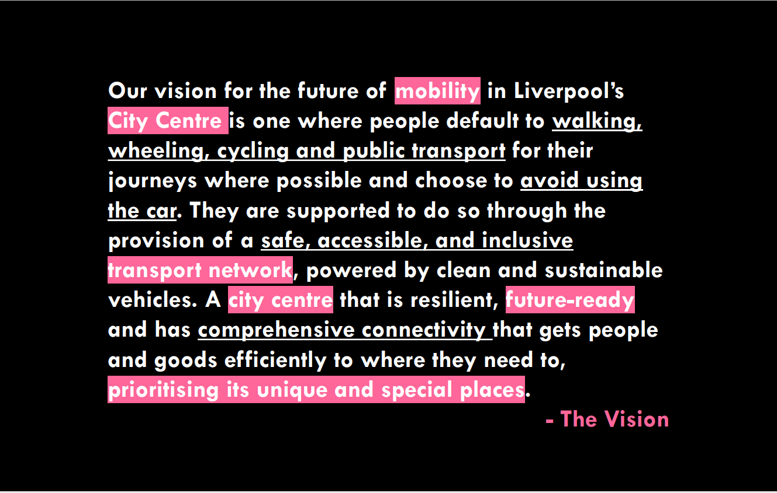

*this is what we should be aiming for in 2035 (the city regions net-zero target is 2035)
The future of mobility in Liverpool is delineated within the broader Liverpool City Transport Plan. This City Centre Urban Mobility & Public Spaces Strategy aims to expand upon the framework of the City Transport Plan, aligning with its vision and principles. The vision, outlined on the previous page, is complemented by four guiding principles that will be used to identify and priority interventions:
• Enabling Sustainable Travel Behaviours: Does the intervention promote and facilitate sustainable travel behaviour?
• Prioritising Active Travel: Does the proposal give precedence to active travel?
• Reducing the Carbon Impact of Travel and Transport: Does the intervention contribute to reducing the carbon impact of travel and transport?
• Maximising the Council’s Commitment and Optimising Resources: Does the intervention maximise the council’s commitments and make optimal use of assets and resources?
Additionally, the City Transport Plan has introduced a new modal hierarchy, which sets a clear agenda for mobility priorities in the city centre. This hierarchical structure is depicted in the adjacent diagram. For the Urban Mobility & Public Spaces Strategy, this modal hierarchy has been extrapolated to set out the future spatial configuration of the city centre. Spatially and strategically, it illustrates how this newly defined hierarchy can manifest in the form and constraints of the city centre.
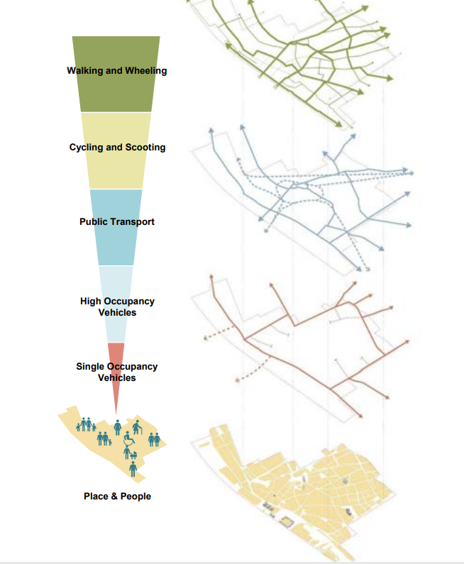
PEOPLE POWER
By 2045, Liverpool will have witnessed a significant shift in people’s travel behaviour. This substantial change in people’s movement habits will need to be effectively enabled by the infrastructure that the city and city region implement*.
Investment in new infrastructure must ultimately work for the people of the city. To unlock a real paradigm shift, schemes and interventions need to make sustainable transport the easiest, cheapest, and most convenient mode of travel. This will make it simpler and more feasible for people to choose greener modes of transport.
*it dosen’t make any sense to have a 2030 net zero target (LCC) or a 2035 net zero target (LCRCA) and then say we aren’t going to achieve these modal shifts in transport until 2045!? Hitting those targets by those deadlines is dependent on decarbonising the transport sector

HOW CAN WE ENABLE PEOPLE TO MAKE BETTER MOVEMENT DECISIONS?
The following four principles will be at the heart of decision-making when supporting people in the city to make cleaner and greener mobility decisions.
- MAKE IT EASY: The easier that sustainable decisions are to make, the more people will make greener decisions and the greater the modal shift.
• Inclusive Design: Develop inclusive signage, streets, transit systems, stations, and stops adhering to the Equality Act 2010, accommodating everyone, including those with protected characteristics.
• Limit Single Occupancy Vehicles: Restrict the cross-movement access of single-occupancy vehicles in the city centre, preventing rat running and promoting well-connected public transport.

• Prioritise Sustainable Movement: Give priority to sustainable movement, ensuring pedestrians have crossing priority at junctions, cyclists have dedicated signalling phases, and transit is prioritised over private vehicles.
- MAKE IT CONVENIENT: The more convenient sustainable transport modes are, the more likely people are to use them.

• Improved Network Coverage: Enhance the coverage of sustainable movement networks, such as public transport and cycling lanes, making them easily accessible and integrated into the overall network.
• Integrated Modes: Enable longer and easier trip chains with integrated modes, incorporating features like cycle storage at transport hubs* and synchronised timetables for buses, trams, and trains

*like have accessible bike storage at train stations!!!!

- EMPOWER AND EDUCATE:
- Public Awareness Campaigns
- Community Workshops and Events
- Educational Programmes in Schools:
- Partnerships with Employers
- Demonstration Projects: Implement demonstration projects to showcase the feasibility and benefits of sustainable transportation initiatives. These projects can include temporary bike lanes and pedestrian-friendly streetscapes. By experiencing these improvements firsthand, residents may be more likely to support permanent changes*

*we’ve been doing all the above for decades with basically zero impact or negligible impact on the numbers of people (% of trips made by bike). They are still important and need to be done but as already acknowledged in this report the only thing that will make a significant difference to the number of people cycling is massively improved infrastructure.
The only thing that hasn’t been tried that much yet, but hopefully will going forward is the demonstration projects, car free days etc.

PLACEMAKING CORRIDORS
Building upon the City Network proposed in the Liverpool Public Realm Strategy, placemaking corridors will serve as the backbone of the city centre's character. These corridors solidify the fabric of the city, its people, and culture, ensuring that these streets prioritise spaces for people (walking, wheeling, and cycling) is essential. Creating a pleasant environment for culture, economic growth, and the city's fabric to thrive is crucial to ensuring Liverpool's city character and sense of place are at the heart of all projects. Movement on these streets should be limited and prioritised to reflect the city's newly defined modal hierarchy, ensuring Liverpool's character and crowning landmarks are easily accessible and protected in the future . . .
The corridors will follow the principles outlined in the design toolkit and the network, supported by secondary routes and linkages, and will deliver strategic walking, wheeling and cycling connectivity across Liverpool City Centre. This will enable people to take ownership of streets . . .
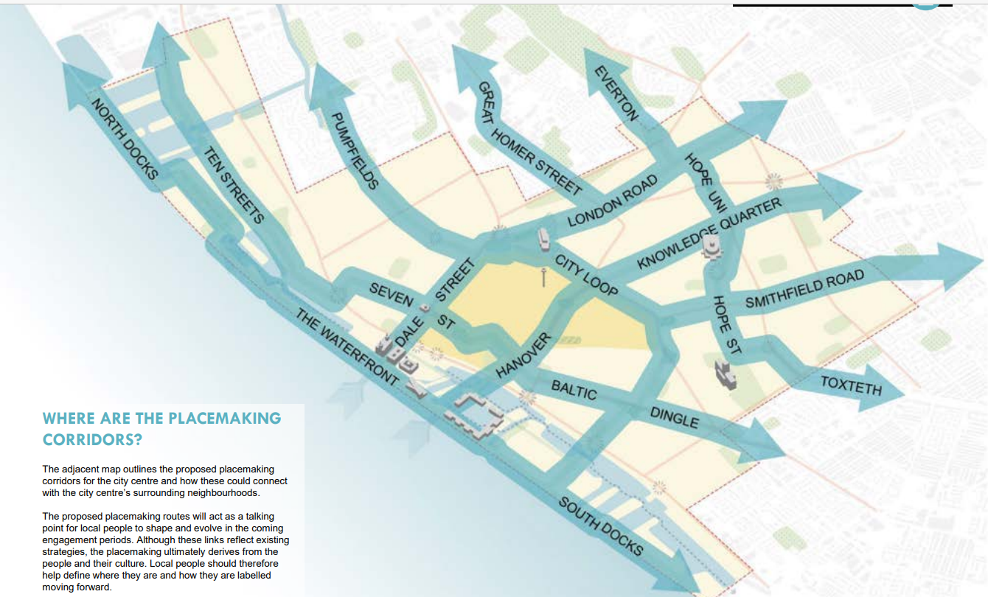

WALKING AND WHEELING PRIORITY
Walking and wheeling encompass a diverse range of mobility needs and preferences, including traditional walking as well as the use of wheelchairs, mobility aids, scooters, prams, and trolleys. This inclusive term ensures that our city's future infrastructure considers the needs of all individuals, regardless of their mode of movement. By prioritising walking and wheeling within our modal hierarchy, we recognise the importance of pedestrian and wheeled mobility as the highest priority in our urban landscape.
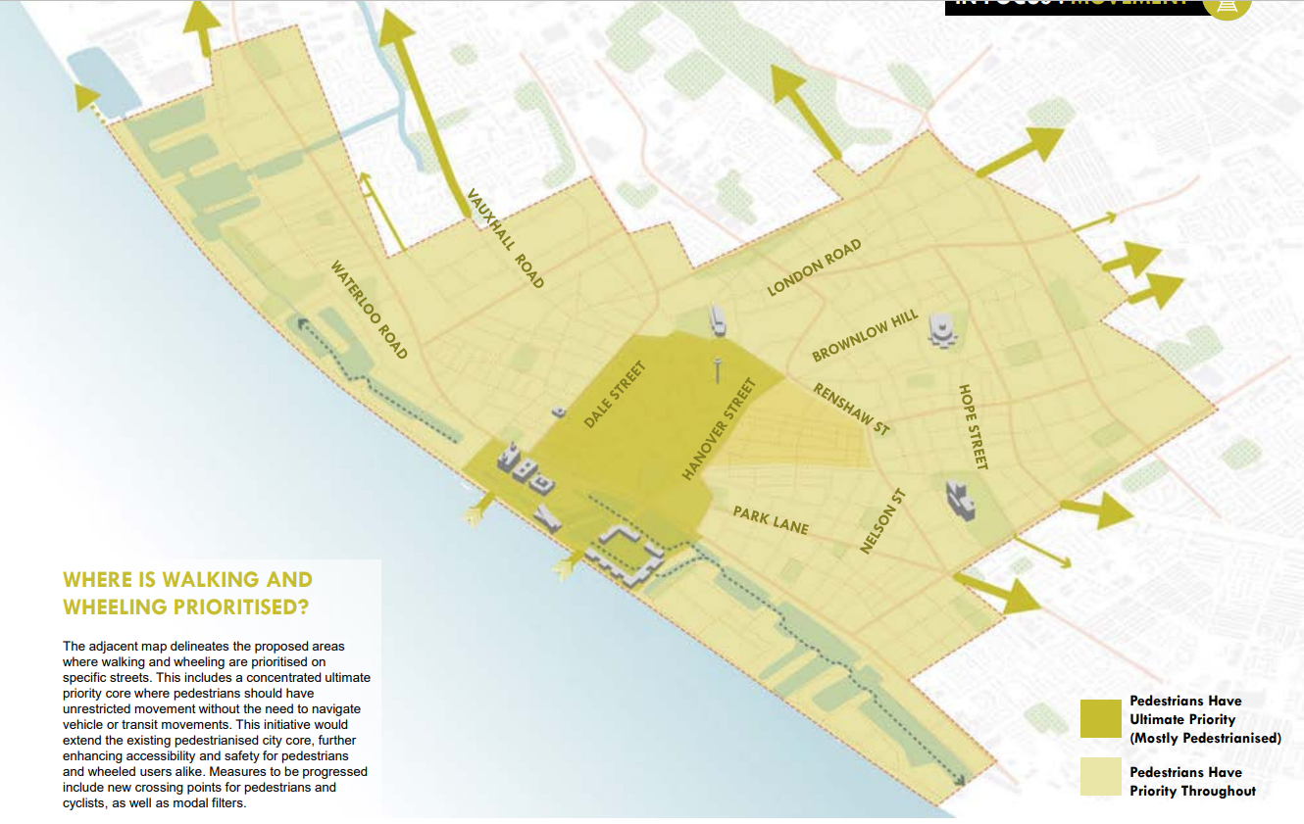

CYCLING CORRIDORS
Connecting a wider catchment of the city's population through cycling is essential for transitioning to sustainable movement and ultimately achieving decarbonisation of the city centre. Cycling infrastructure plays a crucial role in enabling longer trips, connecting communities, and facilitating ease of commuting
Implementing a comprehensive cycling network that connects existing infrastructure and enables cross-city movement is vital for unlocking the cycling potential of the city and its centre. Dedicated cycling lanes, separated from vehicular traffic, ensure safer and more efficient navigation for cyclists. Direct routes linking key destinations within the city centre encourage more people to opt for cycling as their preferred mode of transport, leading to reduced congestion and pollution.

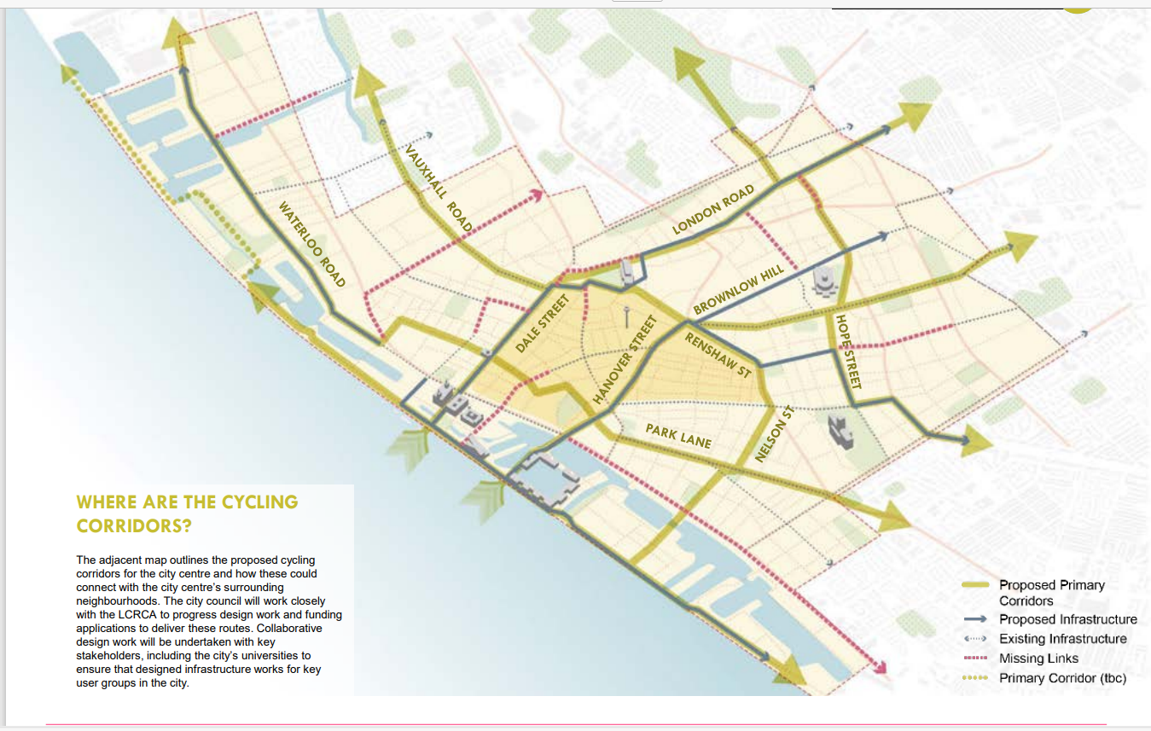

Reduced single occupancy vehicle journeys for an equitable and sustainable future.*
*I think they mean private cars
SINGLE OCCUPANCY VEHICLES
In order to advance towards a more sustainable and efficient future for city centre mobility, it is imperative to reduce the number of vehicle trips, particularly solo vehicle trips. Solo vehicle trips not only contribute to congestion for other motorists but also pose functional challenges for bus services and create hazardous congestion in the city's tunnels, affecting pedestrians and cyclists as well.
While essential vehicle trips, such as those for individuals with limited mobility, will still be accommodated, those who use vehicles for convenience will face premium costs*. Currently, every aspect of city centre mobility is adversely affected by the volume of vehicles present. Issues such as pollution, noise pollution, air quality deterioration, socioeconomic imbalances, and vast expanses of land dedicated to road infrastructure and car parking are all exacerbated.
*just make it virtually impossible to drive through and around the city centre in a private car!!
By reducing car parking within the city centre core and increasing it on the outskirts, enhancing public transport capacity, and eliminating private vehicles through routes within the city centre, drivers will be compelled to adapt and reduce their reliance on vehicles for accessing the city centre. Instead, drivers will need to walk or cycle the final mile of their journey or opt for alternative modes of transportation. Prioritising sustainable and alternative transportation methods will not only alleviate congestion but also foster a more resilient, healthier, and inclusive urban environment for both current and future generations.
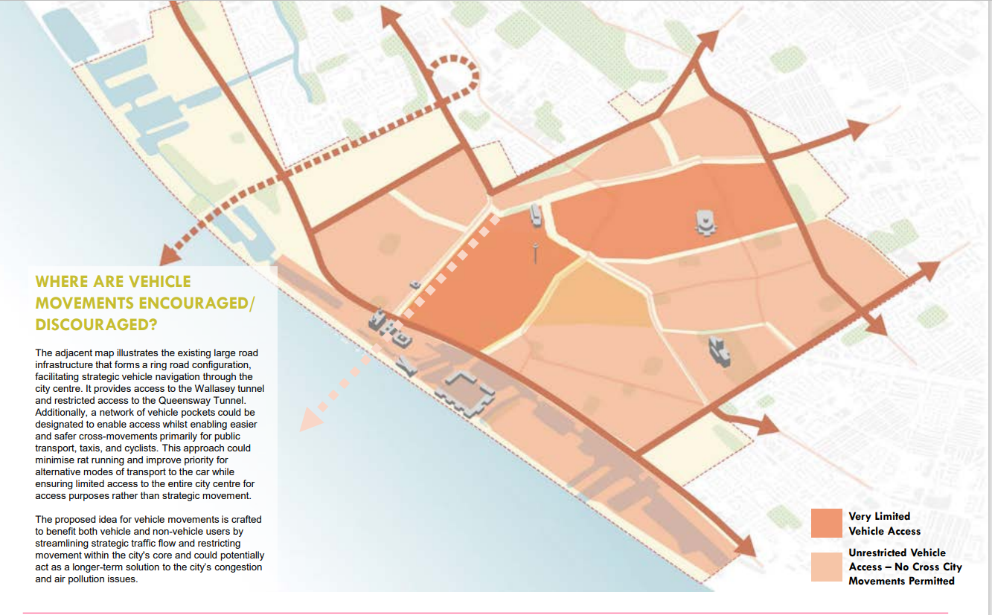

HOW WILL WE MINIMISE THE IMPACT OF CAR USAGE IN THE CITY CENTRE?
- Movement Pockets with Limited Cross Movement: Designating specific areas where cross-city movement for vehicles is restricted, directing traffic around the city centre rather than through it.
- Retention of City Centre Ring Road: Maintaining a ring road around the city centre to encourage vehicles to circumnavigate it instead of passing through, minimising congestion within the core.
- Promotion of Wallasey Tunnel Usage: Implementing pricing structures to incentivise the majority of vehicles to use the Wallasey tunnel, located outside the city centre, for improved traffic flow.*
- Reduction of City Centre Car Parks: Decreasing the number of car parks within the city centre and promoting satellite parking facilities located around the city's perimeter, coupled with walking or cycling opportunities for commuters.
*be more radical. Queensway for Buses, taxis and delivery vehicles only. Private cars have to use the Kingsway
HOW CAN WE IMPROVE CROSS RIVER MOBILITY?
Downgrading The Queensway Tunnel for Public Transport: Consider repurposing the Queensway Tunnel for public transport and local journeys exclusively, reducing congestion in the city centre and ensuring the reliability of public transport.

Quick wins – Castle Street
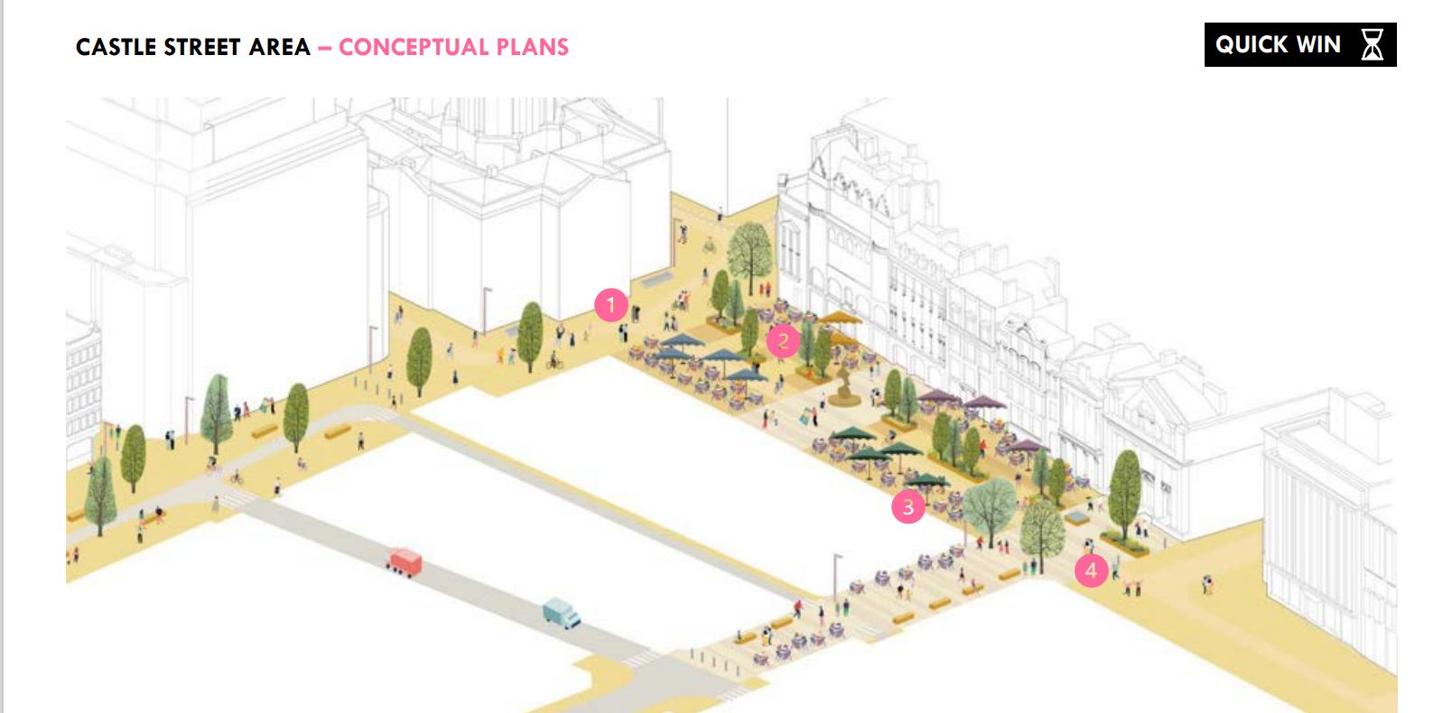

This will involve the pedestrianisation of sections of Water Street and Brunswick street.
- Town Hall Square To celebrate the Town Hall, a square with limited planting and seating at the edges has been proposed in front of the building across the width of Dale Street
- Greening Up A variety of green infrastructure could not only provide a cooler environment during heat waves, but also improve biodiversity in the city centre.
- Outdoor Dining Spill out spaces are already a bit part of Castle Street, however, a better structure would improve the image and accessibility of the street
- Bank Square A long vista from the waterfront culminates at the Bank of England building. This has been identified as a key view and a square has been proposed to secure that.

Central (Station) Square – quick win
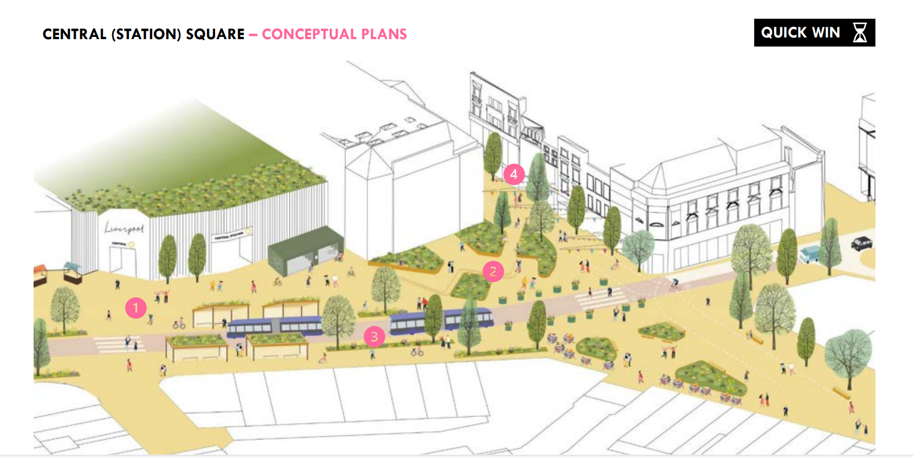

- Station Arrival Retail and fast food units onto Hanover Street as part of the station complex are removed to create an arrival experience and expose main entrance to the station
- Station Square A singular, unified space is designed on the south side of Hanover Street to provide waiting areas for passengers and create a gateway to Bold Street
- Hanover St Hanover Street becomes part of a greater Central (Station) Square with bus gate located at junctions on each end to prevent private vehicles driving through
- Bold Street Permanently pedestrianised Bold Street with time restricted access allows for more formalised spill outs without impacting the pedestrian through movement.

Monument place – quick win
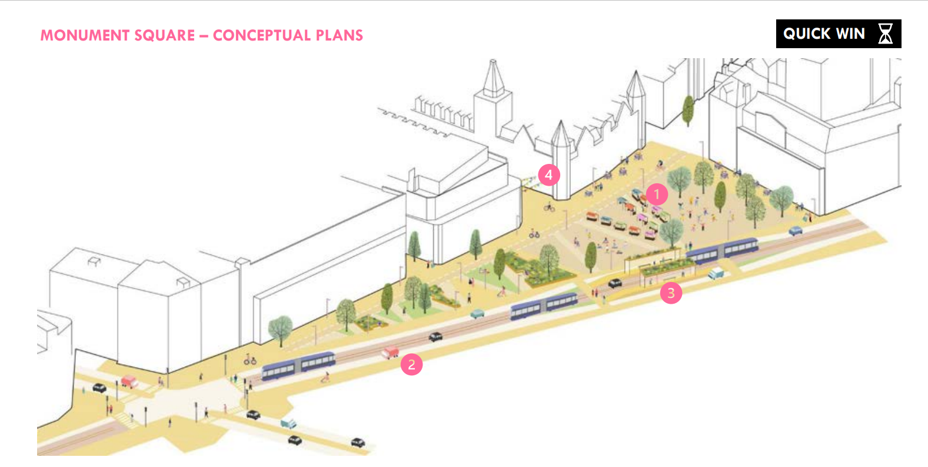

- The Market Market is a distinctive part of the character of Monument Place and should be better integrated in the space, providing more uniform market stalls
- London Road Character of London Road requires a significant shift towards sustainable travel. The space for private vehicles along this corridor should be reduced and priority given for tram-style movement
- Hop On / Hop Off Bus movement along London Road dominates the space. Bus shelters should be pushed away from the space to reduce the impact of vehicular movement
- Celebrating Side Streets Monument Place should be the heart of both Fabric District and Islington. Celebrating the side streets leading towards the space will integrate it better in the wider neighbourhood.

B. KICK START ENGAGEMENT AND DATA GATHERING AND OTHER COMPLIMENTARY PROJECTS
Community Engagement and Consultation:
Undertake extensive engagement with local residents, businesses, students, and visitors to shape the Urban Mobility & Public Spaces Strategy. This collaborative approach will leverage local knowledge and ensure that the strategy reflects the needs and aspirations of the community. This should include
• Targeted engagement with businesses and key stakeholder
• Installations and events to celebrate and promote the city centre’s future.*
*car free days?

Data Collection
Conduct comprehensive data collection, including traffic counts, flows, and traces across the entire city centre. This data will establish a robust foundation for decisionmaking and inform future proposals aligned with the city's long-term goals. Continue monitoring air quality to assess the effectiveness of mobility initiatives and identify areas for improvement. Regular monitoring will help track

Complementary Projects
The following key interventions should also be undertaken to prepare for further evolution of the city mobility plan this should include
• Experimental Closures and Trials: Utilise Experimental Traffic Regulation Orders (ETROs) to trial proposed schemes and gather data. These trials can engage the public, collect valuable data, and inform future mobility strategies based on real-world observations.
• Progress on Bus Priority: Collaborate with the combined authority to implement Green Bus Routes and prioritise bus services for improved reliability. This initiative sets the stage for future bus rapid transit projects and demonstrates the city's commitment to public transport, providing priority, better service and in turn a more attractive network.

Q. WHAT CAN WE DO TOMORROW?
A. UNDERTAKE ENABLING PROJECTS
The following list of schemes and interventions should be undertaken as part of the process of moving city centre mobility towards the city’s 2045 vision*
*2045! This needs to be done by 2035 at the latest!
This list however is not exhaustive and is flexible to the changes in demand, funding opportunities and priorities over the coming 20 years.
• Upper Central Masterplan revisit with new mobility plan at the heart of proposals (Mount Pleasant Car Park future development).
• Strand Phases 2 & 3 should look at prioritising cycling, pedestrians and a new north/south bus/BRT lane
• St George’s Gateway building upon the quick win scheme evolving the area to a city gateway rather than a throughfare as outlined in the Public Realm Strategy.
• Dale Street enhancement and downgrading to general access.
• Bath Street upgrades and active travel corridors
• Undertake Hanover Street/Central Station reimagined scheme, with a masterplan of the adjacent area and improvements to rail capacity for Central Station.
• Bold Street public realm and formalised pedestrianisation.
• Fabric District public realm and Finch Place Square creation
• Consolidating the Baltic Triangle, consolidating Baltic Triangle parking creating mobility hubs and public realm.
• London Road narrowing and formalisation of on-street parking with public realm enhancements.
• Hardman Street/Leece Street corridor improvements and enhanced public realm*
*there are lots more, these were the ones that are most interesting to me

Cycling and Walking Infrastructure:
• Combined Authority missing Links Cycle Lanes.*
• Cycle lane extension/footway widening along Wapping to the Strand.
*is this Simons thing?
• Connected Leeds Street cycle lane, Pall Mall, Vauxhall Road and down to Old Hall Street.
• Hanover Street/ Duke Street crossing enhancements.
• Georgian Quarter crossing updates, including new push button crossings on Catherine Street and formalisation of parking, crossing between parking lengths, narrowed crossing heads, on-street cycle parking.
• Super crossing at the Adelphi/Renshaw/Brownlow Hill junction.
• Grafton Street/ Parliament Street super crossing.*
*there are more, these were the most interesting ones to me

Other proposals and schemes –
• Downgrading of all A routes in the city centre core to reduce rat running and vehicle volumes.

B. APPLY THE DESIGN TOOLKIT & 2045 PRINCIPLES TO ENABLING PROJECTS
The previous list of schemes and any schemes proposed in the city moving forward should align with the principles and themes outlined in the City Centre Mobility 2045 Vision. Additionally, these schemes should adhere to the guidelines provided in the following design toolkits:
• Modal Hierarchy in Action: The design toolkits provide guidance on prioritising different modes of transportation within street corridors. This hierarchy should be followed to ensure that each scheme emphasizes the most efficient and sustainable modes of travel.
• Spatial Ratios and Relationships: The toolkits outline the spatial relationships between different elements within street corridors, such as pedestrian pathways, cycle lanes, public transport stops, and vehicle lanes. These ratios should be applied to ensure that each scheme optimises space usage and promotes safe and efficient movement for all users.
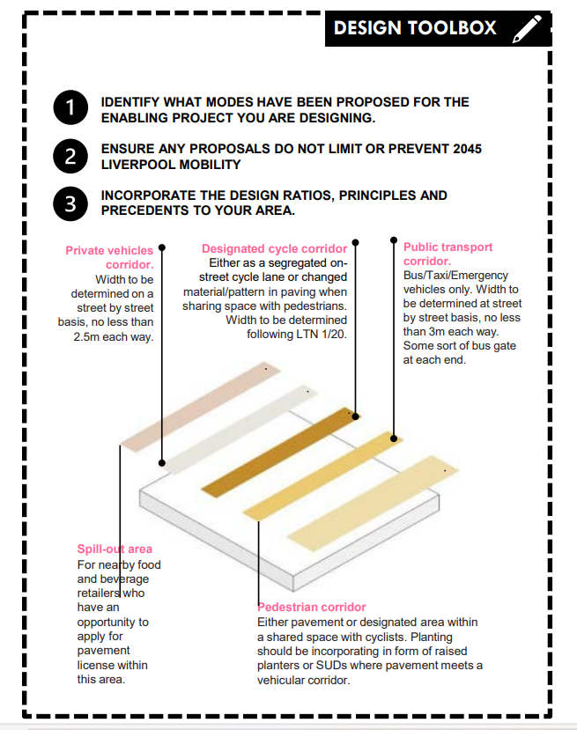

8.0 SUMMARY& NEXT STEPS
Summary The report presents a strategic framework aimed at reshaping the city centre's mobility landscape, guided by a set of key principles. These principles are designed to foster sustainable travel behaviours and ensure equitable access to transportation options for all residents. They include:
• Modal Hierarchy Spatial Application: The strategy emphasises the spatial application of the city's modal hierarchy, with a focus on promoting walking, cycling, and shared vehicle usage. This approach aims to optimise the use of urban space and support modes of transport with lower environmental impacts.
• Behavioural Change and Accessible Transport: An integral aspect of the strategy is to catalyse behavioural change and enhance accessibility to transport options, especially for underserved communities. By providing better alternatives to private car usage, the plan aims to address mobility disparities and promote inclusivity.
• Enabling Sustainable Travel Behaviours: The strategy evaluates interventions based on their capacity to encourage sustainable travel behaviours. Initiatives prioritising active modes of transport and public transit are prioritised to mitigate emissions and promote healthier urban environments
• Prioritising Active Travel: Active travel modes, such as walking, wheeling and cycling, are given precedence in the strategy to foster physical activity, alleviate congestion, and improve air quality. This prioritisation underscores the city's commitment to creating healthier and more liveable urban spaces.
• Reducing Carbon Impact: Efforts to reduce the carbon impact of travel and transport are central to the strategy. By promoting greener forms of transportation, such as public transit and cycling, the plan seeks to minimise the environmental footprint associated with urban mobility.
• Reducing the Impact of Private Vehicles: Restricting through vehicle movements in designated areas to prioritise transit, pedestrians, and cyclists, thereby improving overall mobility efficiency.
• Delivering Safe and Attractive Walking & Cycling Corridors: Enhancing safety and accessibility for pedestrians and cyclists across the city centre, promoting active transportation and healthier lifestyles.

Next Steps
The strategy is designed to evolve alongside the city's growth and development, serving as a catalyst for discussions, proposals, and stakeholder engagement. Moving forward, the next steps include:
• Technical Studies: Undertaking in-depth technical optioneering and design studies to refine and optimise proposed ‘Quick Win’ interventions over the next 12-18 months.*
• Feasibility and Supporting Strategy Documents: Undertake further feasibility and strategy work to understand in greater detail the principles within the report this could include:
*Does this mean that the “quick wins” won’t be delivered for at least 12-18 months?
• Engaging Key Stakeholders: Initiating discussions with key stakeholders including business and tourism groups, key employers and academic instructions to gather feedback and build support for the proposed initiatives.
• Public Engagement: Proactively sharing the initial proposals and principles outlined within this strategy with key stakeholders and the public to generate interest and involvement in the Urban Mobility & Public Spaces Strategy, empowering the community to make informed decisions about cleaner and greener mobility options, and ultimately supporting local people to shape the future of mobility in the city centre.

